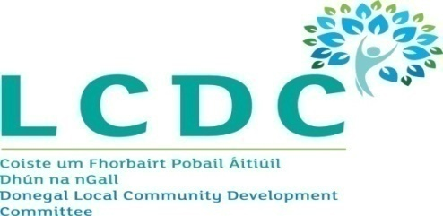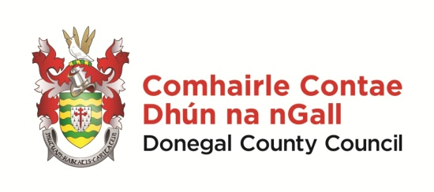

Minutes of Donegal Local Community Development Committee
County House, Lifford, 10.00 am on 19th November 2018

Members | Clr Martin McDermott (Chair), Seamus Neely, Clr Maire Therese Gallagher, Martin McBride, Anne McHugh, Padraig Fingleton, Fionan Bradley, Susan McLaughlin, Siobhan McLaughlin, Michael MacGiolla Easbuig, James O Donnell and David Alcorn
Apologies | Clr Niamh Kennedy, Aengus Kennedy, Paul Hannigan, Liam McElhinney and Susan McCauley
Chief Officer | Paddy Doherty
Attending | Seamus Canning, Adrienne Kelly & Kathleen Browne

Welcome

Clr Martin McDermott, Chairperson, welcomed everyone and thanked the members present for attending the meeting.

- Minutes of Previous Meeting
Draft minutes of the LCDC meeting of 15th October 2018 were considered. The minutes were proposed by Martin McBride and seconded by James O Donnell.

- Matters Arising
Clr Maire Therese Gallagher queried the number of submissions returned as part of the Happiness Survey. Paddy Doherty advised that the final figure was not available yet and confirmed that a full report on the Survey would be presented at the LCDC Meeting in December.

- Developing Local Migrant Integration Strategies
Clr McDermott welcomed Mr Joe O Brien, Integration Outreach Officer, Immigrant Council of Ireland to the meeting. Mr O Brien made a presentation to members present on the discussion document and proposed actions for Local Authorities on developing local migrant integration strategies, which had been circulated with the Agenda.

Mr O Brien’s presentation covered the following:-

- Outline of the background to the Immigrant Council of Ireland and their work.
- Review of previous local strategies,
- Results of the 2017 Survey of Local Authorities on local migrant Integration strategies
- Key principles and proposed actions for Local Authorities to adopt.

In summary he called on Local Authorities and the LCDC to use the full extent of their functions, events and consultations in a targeted way as opportunities to engage with migrants in their area.

Siobhan McLaughlin welcomed the presentation and felt that it was timely in light of the Peace IV Grants process. She advised that alot of the recommendations in the report were included in the Peace Plan.

Padraic Fingleton confirmed that New Communities were a target group in the SICAP Programme and DLDC and IDP were working on this with the Intercultural Platform.

Clr Maire Therese Gallagher thanked Mr O Brien for his presentation and agreed that it was important to ensure that its recommendations were included in policy documents. She felt it was important that the Department assist local authorities with funding and direction on this matter.

Seamus Neely referenced the success of previous integration projects in Donegal. He stated that whilst Donegal were fortunate to have the Peace Programme and funding available to them it was important not to assume that this was enough. He called for all funding and programmes available to other counties to be made available to Donegal also.

Siobhan McLaughlin advised that during a recent visit to the County Minister Staunton had been requested to provide resources for an Inclusion Officer to work with Donegal County Council and the LCDC. She also suggested that a seat be made available on the PPN secretariat for Migrant Communities representative.

Mr O Neill thanked members for allowing him to attend and confirmed he was available to assist with any queries.

- AOB
Martin McBride queried the position on the Donegal LCDC Equality and Human Rights Statement. Clr McDermott confirmed that a draft Statement had been prepared was now being reviewed.

- Date of next meeting
Members were advised that the next meeting of the LCDC would be held at 2pm on Tuesday, 18th December in County House, Lifford, and directly followed by the LAG meeting at 3pm.

This concluded the business of the meeting.

